**Video interviewing guidance for candidates**

Important user information for video interviewing

**You will be sent an invitation to a Microsoft Teams interview. Please accept this invitation to secure your interview slot.**

Once you have accepted the invite, the interview should move into your calendar. You should try to ensure that you are logged into the MS Teams call a few minutes before your interview is due to start.

To be able to join the interview you will need access to a SMART device such as a smartphone or tablet in order to get access to Microsoft Teams either in your browser, or if you have the desktop app downloaded in the application. Alternatively, you may have a laptop or computer with the right accessibility.

You do not need to download the Microsoft Teams desktop application to get access to the interview. After going to meeting invite, select “Click here to join the meeting”. This will open a web page where you will see two choices: “Download the Windows app” and “Join on the Web”. If you do not have the desktop application downloaded, select “Join on the Web”. For best quality and speed make sure to use Microsoft Edge or Google Chrome.

Please note – when prompted, you must allow Microsoft Teams to access to your camera and microphone which will enable you to be seen and heard in your interview. Failure to do this may compromise the ability to undertake a video interview.

How will it work?

This guide is for people who are new to Microsoft Teams, and provides information on how to use it to take part in video interviewing for DWP vacancies.

**Instructions for candidates**

1. You will be invited to a Microsoft Teams meeting from a member of DWP staff.

2. Look for your invitation in your Outlook calendar or your email inbox.

3. About 5 minutes prior to your interview slot (sooner if you want more preparation time), select / click on the “Click here to join the meeting” link in the invite you were sent.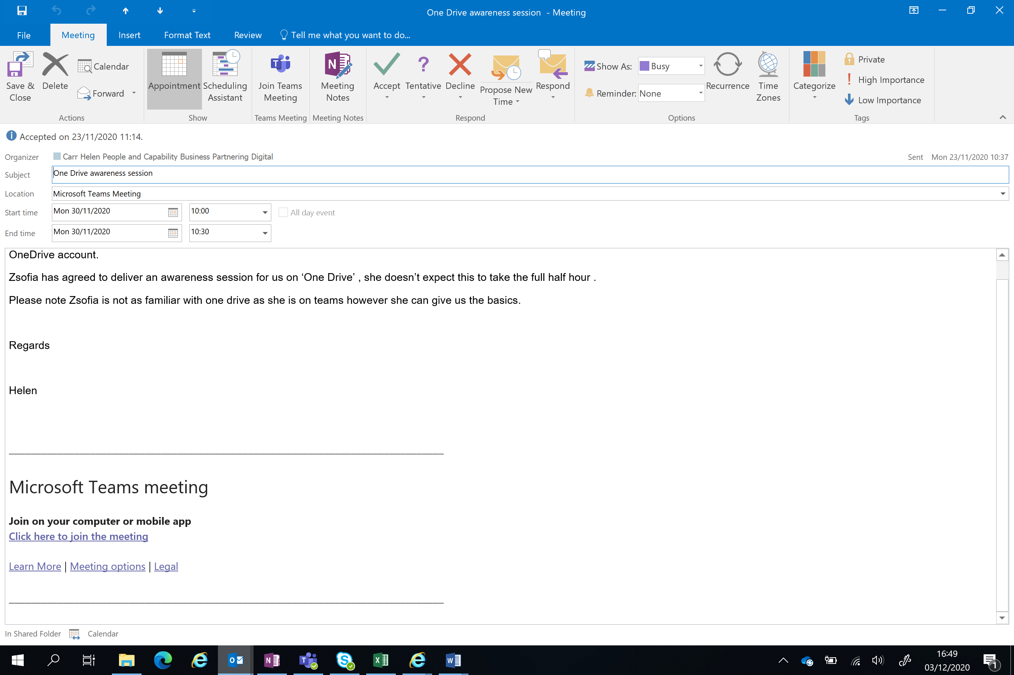

4. That will open a web page, where you'll see two choices: Download the Windows app and Join on the web. If you join on the web, you can use either Microsoft Edge or Google Chrome. Your browser may ask if it's okay for Teams to use your mic and camera. You must allow this so you can be seen and heard in your Interview.

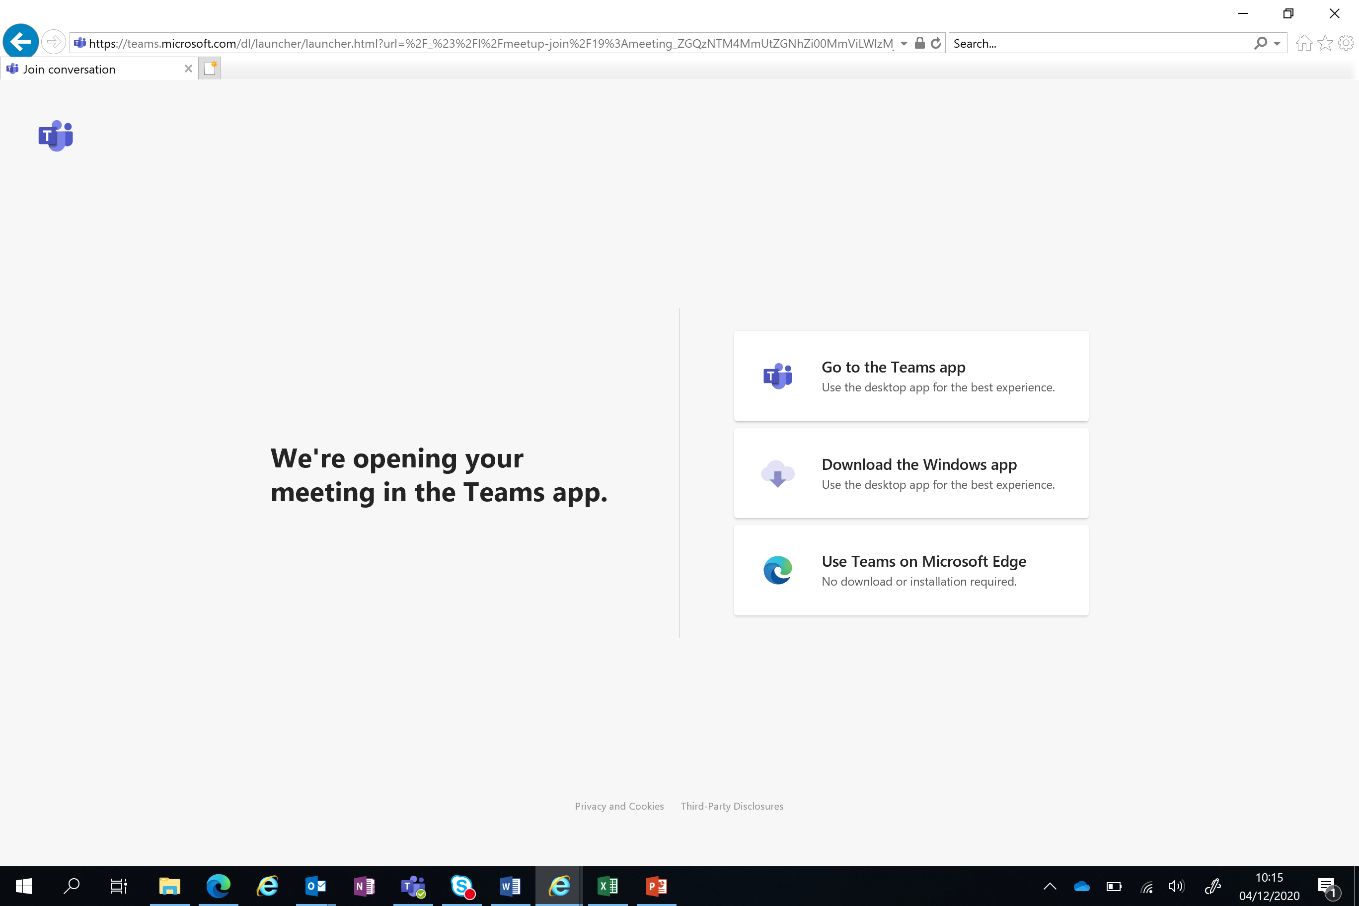

5. Enter your name (this will be displayed during the video interview) and choose your audio and video settings. When you're ready, hit Join now.

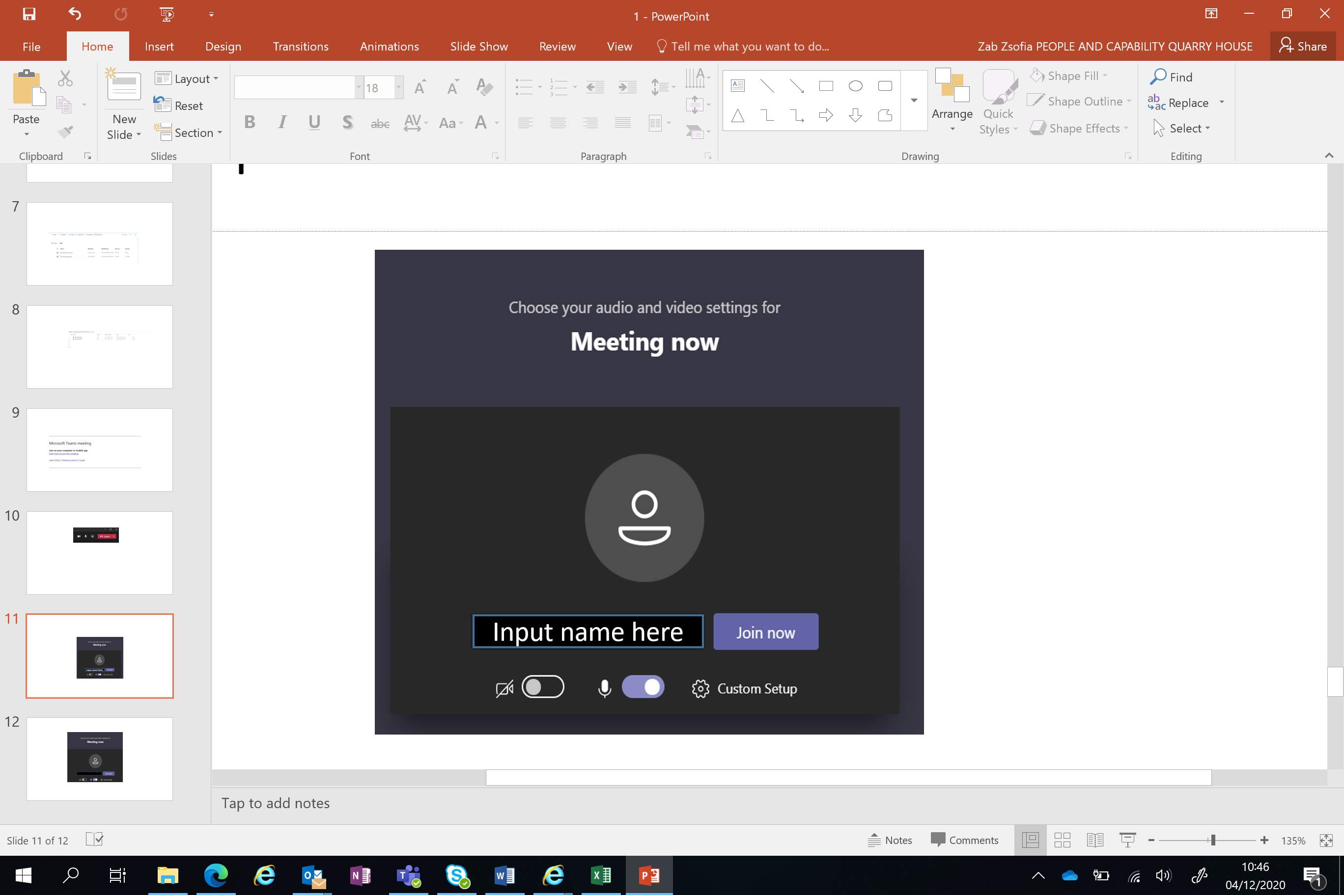

6. This will bring you into the meeting lobby and notify the meeting organiser that you're there. When they are ready to start the interview someone in the meeting will admit you.

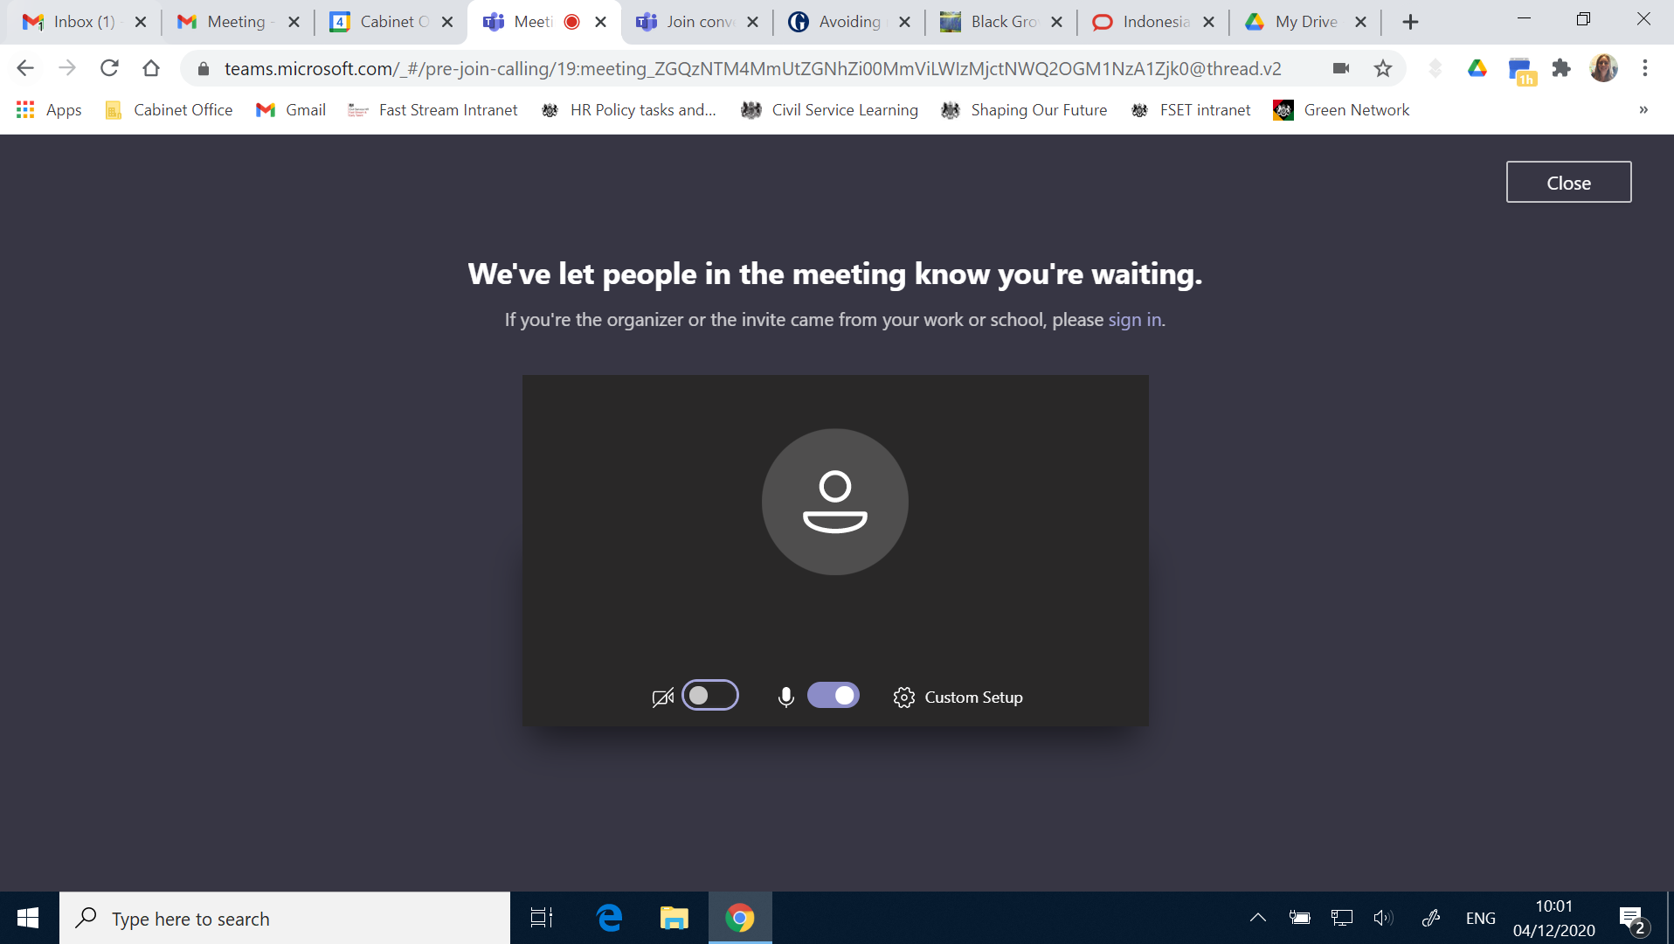

7. When you first join the call, you will find that your microphone is on ‘mute’ so you will need to ‘un-mute’ it by selecting the ‘microphone’ button.

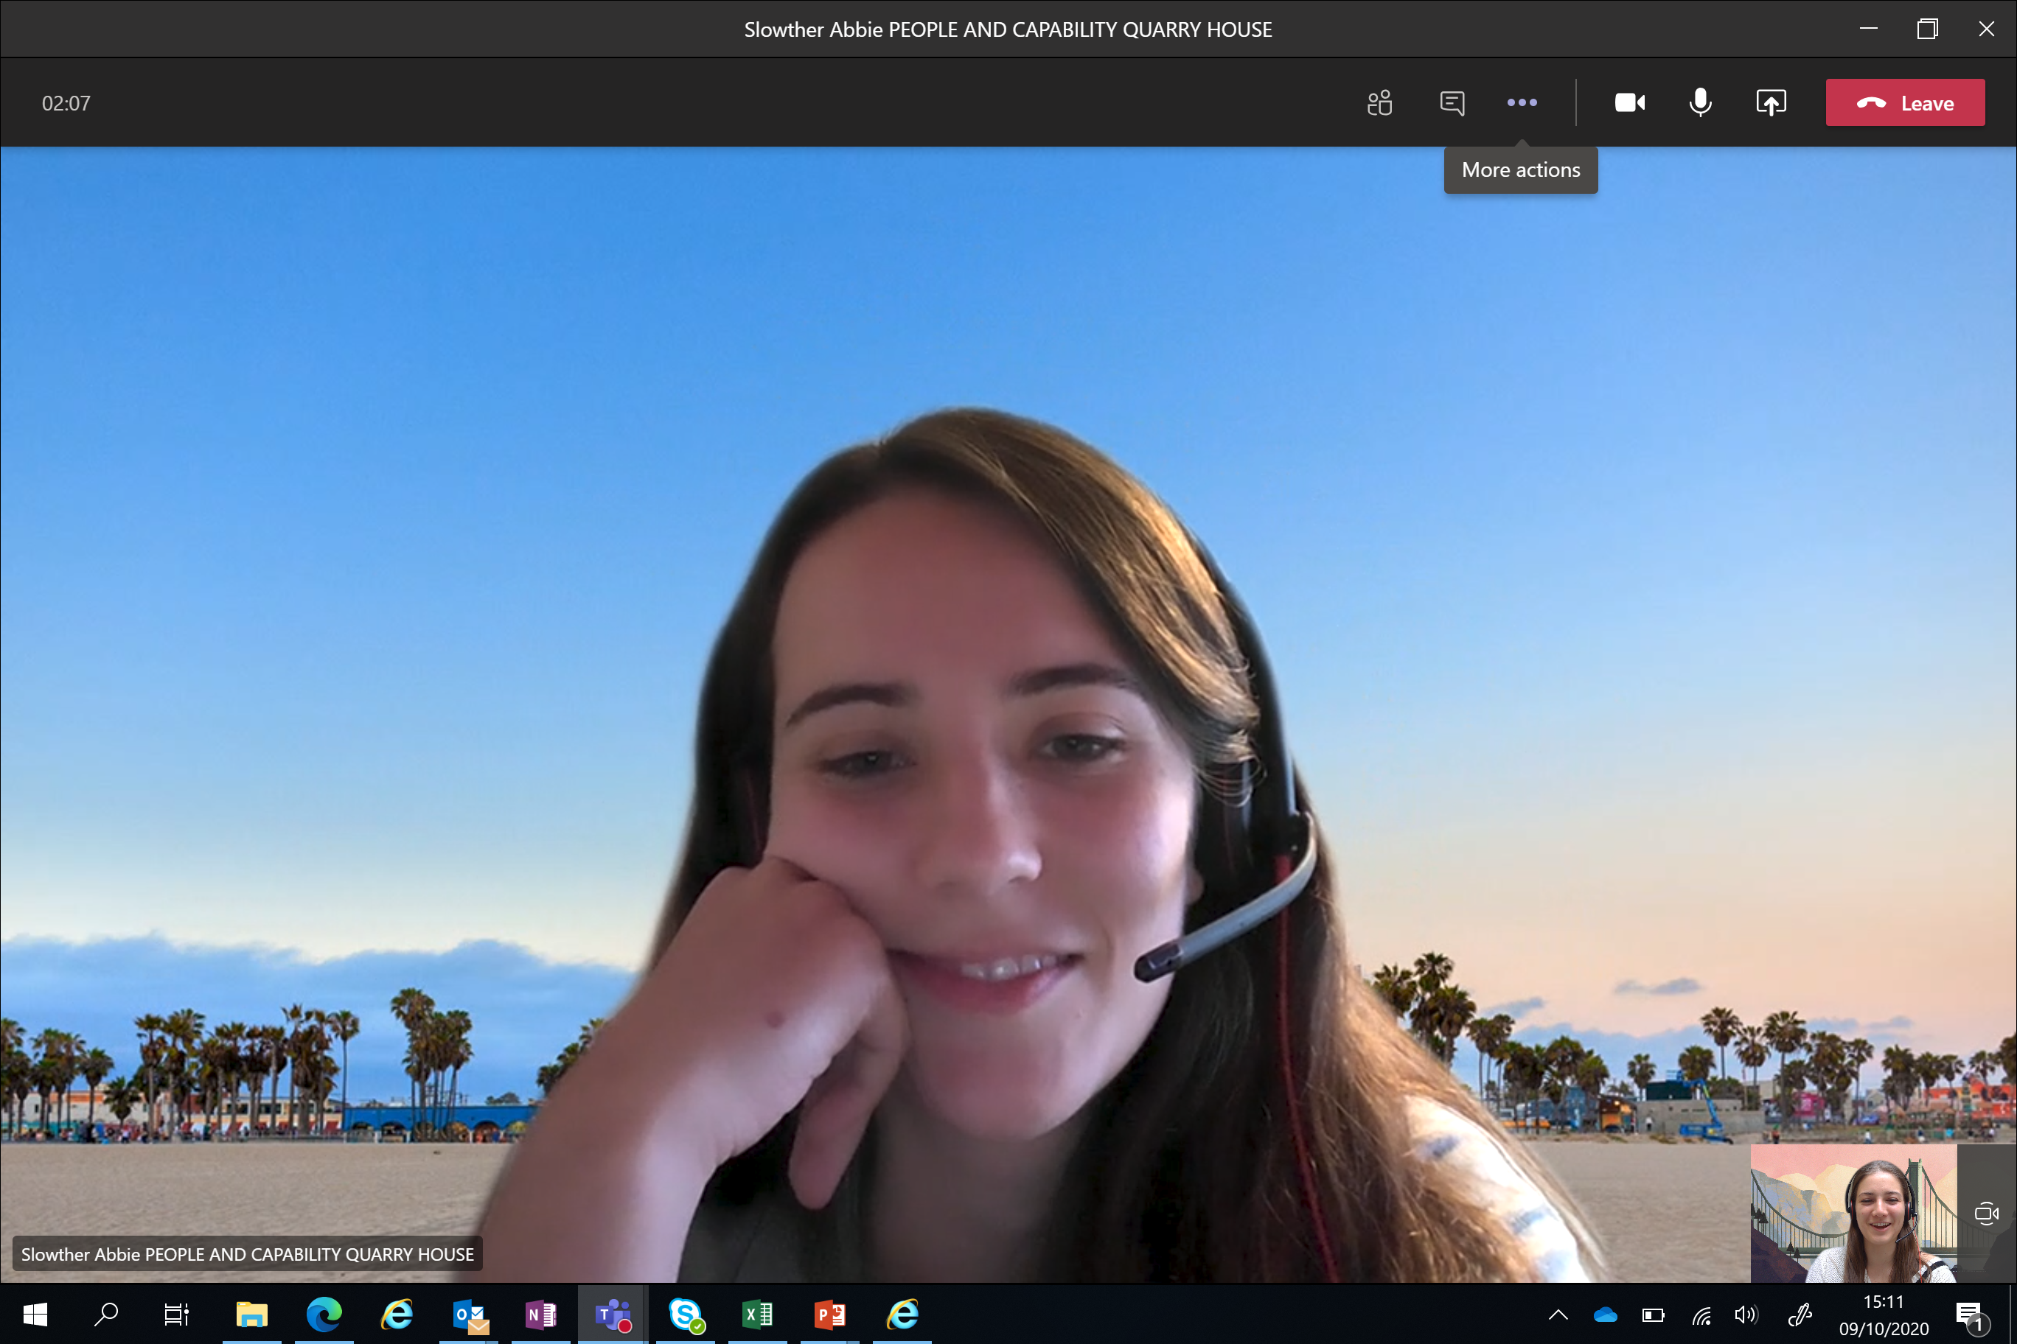

If using a mobile phone, your screen may look a little different, but the icons will be the same.

8. Ensure that you have your camera on during your interview. (If the icon is crossed over, your camera is off)



NB – If your video or audio does not work, please check that you have allowed the App/programme access to your microphone and camera via your device settings.

10. Once the video interview is complete you end the call by selecting the red ‘handset’ button.



In the event that you join the meeting but your panel don’t, please remain logged in for 10-15 minutes, in case this is a technical issue. If after this time no one is available to speak to, please log out of your interview and send an email to the address you received your Microsoft Teams interview invite from in the first instance. Further instructions will then be given.

To help you with your interview, please see below some guidance notes for you.

Microsoft Teams video guidance for candidates

**1. Accept the invitation that has been sent to you** – Please make sure that you have responded to your invite to the interview to confirm your attendance.

**2. Email copies of your ID prior to your interview** – Please send a scanned copy/photograph of your ID to the email address that you receive your Teams Interview invite from. Please do not send to GRS.

**3. Have you given the App / Programme access to your microphone and camera** – Check that you have given the programme access to your microphone and camera. If you haven’t, you may need to check your settings prior to your interview.

**4. Be on time** - Ensure that you are well prepared and join at least 2 minutes before your scheduled interview time.

**5. Right to work document** - Please have all the correct documentation documents that you would usually bring to your interview with you (the exact same ones you have already emailed in step 2). You will be asked to show these to the Interview panel by holding them up to the screen.

**6. Hear and be heard** - Make sure that you have the volume and microphone set properly so the interviewers can hear you and you can hear them.

**7. Dress appropriately** - Dress as you would for a face to face interview.

**8. Consider your environment** - Is it quiet and distraction free? Is the lighting good and visibility clear? What will the interviewers see behind you? Make sure you are the main focus with nothing distracting in the view of the camera.

**9. Make sure that you won’t be distracted** - Shut down other programmes on your device. Make sure there aren’t any notifications that will make a noise. Switch off your phone.

**10. Don’t be disturbed** - If there are other people about let them know that you are being interviewed and don’t want disruptions. Put pets in a different room and close doors where possible.

**11. Using Notes** - You may use notes but make sure that they are short reminders so that you can keep your focus on your interviewers. This will ensure that you can retain eye contact as much as possible.

**12. Practice**. - It’s a good idea to practice with someone beforehand and get feedback on the environment, lighting, your posture and tone.

Please contact [dwprecruitment.grs@cabinetoffice.gov.uk](mailto:dwprecruitment.grs@cabinetoffice.gov.uk) if you have any questions.